LAPORAN PRAKTIKUM
MATA KULIAH PEMROGRAMAN WEB



Oleh:
Davin Aileenskie Sofiandy
707012500135
D4SIKC 49-04

PROGRAM STUDI S.Ter SISTEM INFORMASI KOTA CERDAS
FAKULTAS ILMU TERAPAN
UNIVERSITAS TELKOM
BANDUNG
2026

Tujuan Praktikum
Praktikum ini bertujuan agar mahasiswa mampu memahami cara menyambungkan database MySQL

Alat dan Bahan
- Laptop
- Internet

Langkah – Langkah Praktikum
Baca modul yang diberikan terlebih dahulu, lalu kerjakan di VSCode
Hasil dan Program

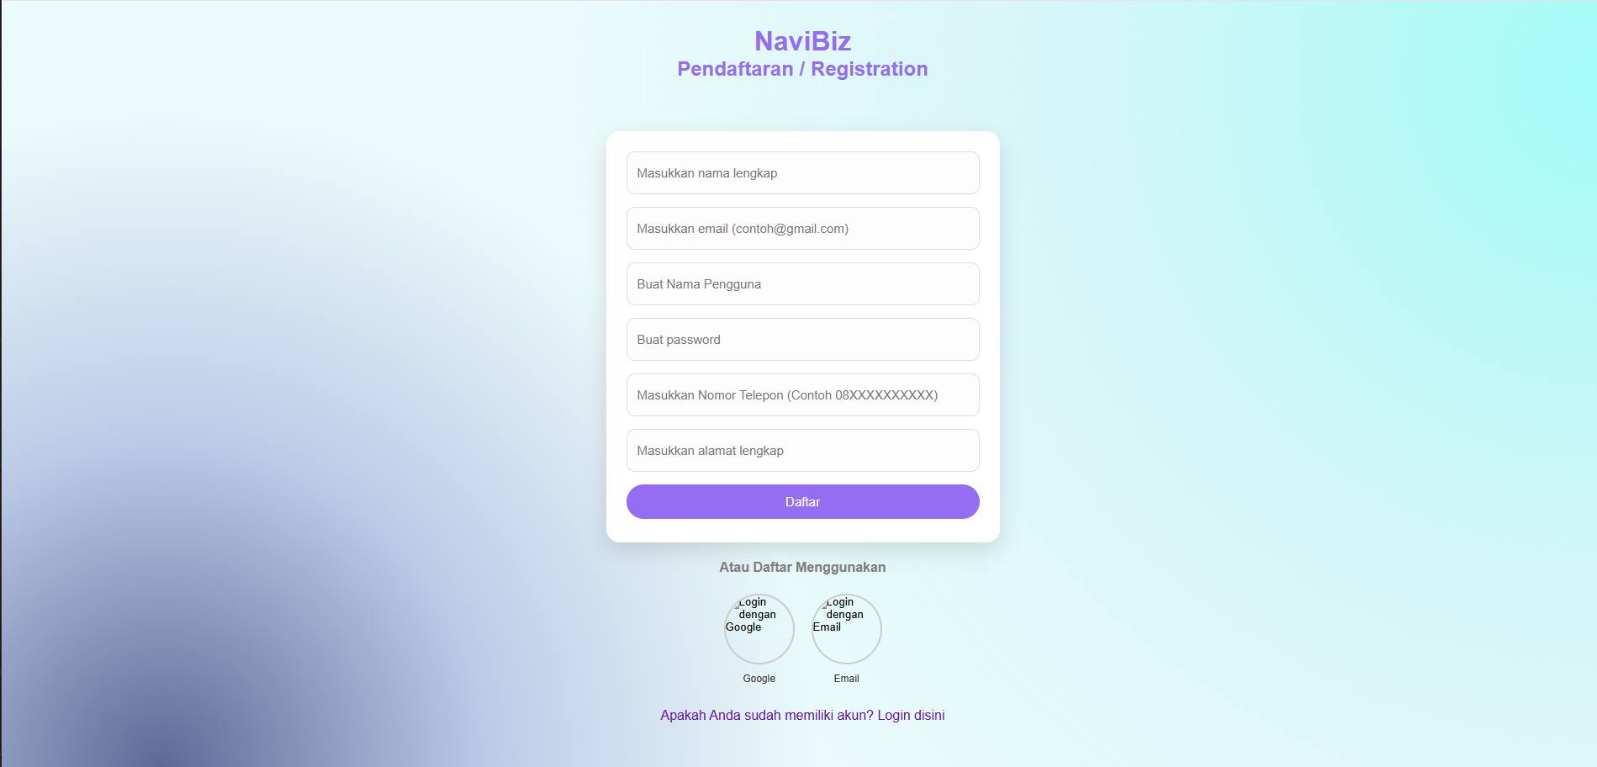
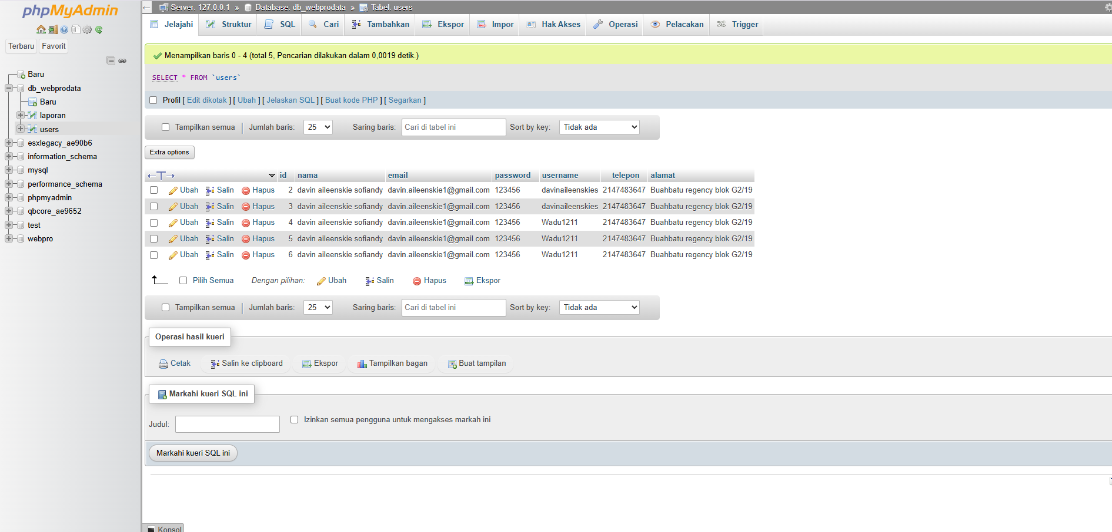

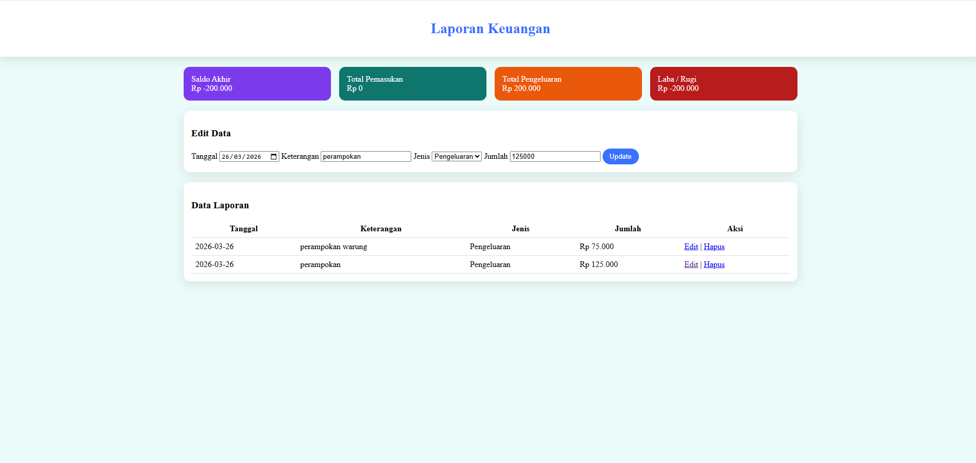
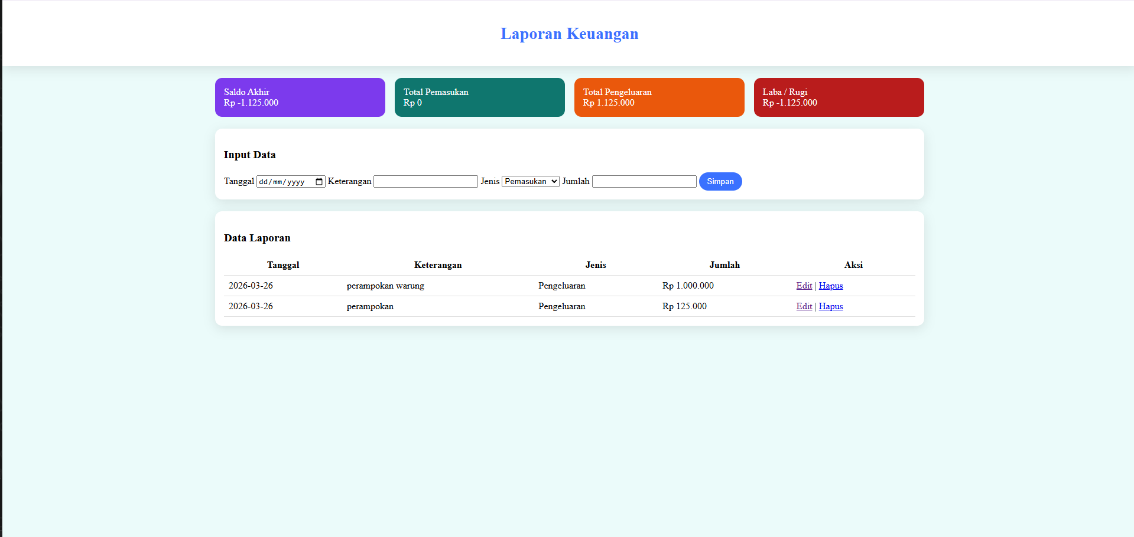
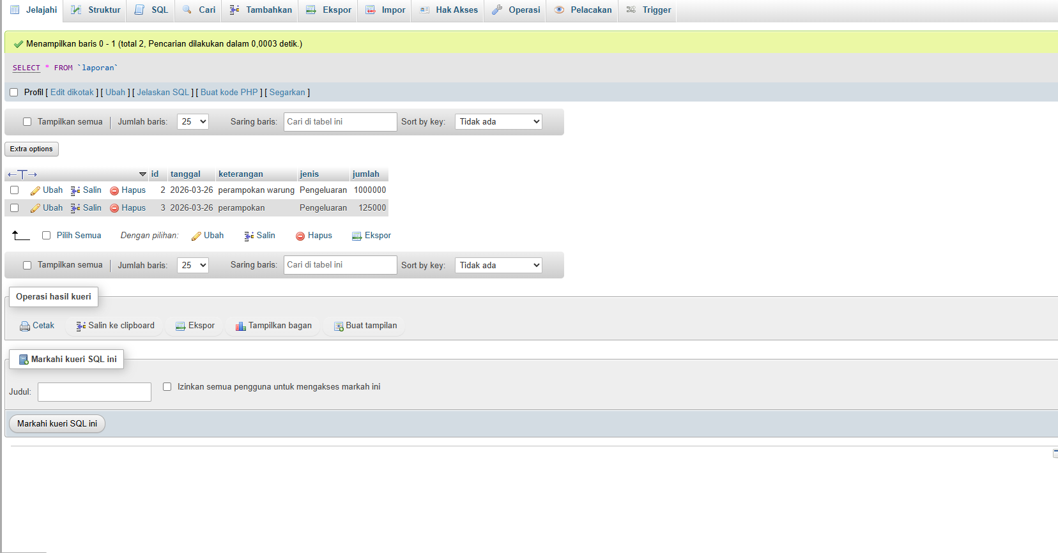

Analisis dan Pembahasan
pendaftaran
<?php

// include("koneksi.php");
$host = "localhost";
$username = "root";
$password = "";
$database = "db_webprodata";

$conn = new mysqli($host, $username, $password, $database);

if ($conn->connect_error) {
die("Koneksi gagal: " . $conn->connect_error);
}
if (isset($_POST["username"])) {
$nama = $_POST["nama"];
$email = $_POST["email"];
$password = $_POST["password"];
$username = $_POST["username"];
$telepon = $_POST["telepon"];
$alamat = $_POST["alamat"];

$sql = "INSERT INTO users (nama, email, password, username, telepon, alamat) VALUES (?, ?, ?, ?, ?, ?)";
$stmt = $conn->prepare($sql);

if (!$stmt) {
die("Prepare gagal: " . $conn->error);
}

$stmt->bind_param("ssssss", $nama, $email, $password, $username, $telepon, $alamat);

if ($stmt->execute()) {
echo "Data berhasil disimpan";
} else {
echo "Execute gagal: " . $stmt->error;
}

$stmt->close();
$conn->close();
}
header ("dompet.php");
?>
<!DOCTYPE html>
<html lang="in">

<head>
<meta charset="UTF-8">
<meta name="viewport" content="width=device-width, initial-scale=1.0">
<title>Form Pendaftaran</title>

<style>
body {
font-family: Arial, sans-serif;
margin: 0;
min-height: 100vh;
background-color: #ebfbfa;
background-image:
radial-gradient(circle at 10% 100%,
rgba(5, 12, 87, 0.607),
rgba(70, 79, 184, 0.281),
transparent 40%),
radial-gradient(circle at 100% 10%,
rgba(60, 252, 242, 0.42),
rgba(207, 244, 248, 0.756),
transparent 60%);
background-repeat: no-repeat;
background-attachment: fixed;
}

.form-container {
width: 100%;
display: flex;
justify-content: center;
margin-top: 60px;
}

.form-box {
width: 100%;
max-width: 420px;
background: #ffffff;
border-radius: 16px;
box-shadow: 0 10px 25px rgba(0, 0, 0, 0.12);
padding: 24px 24px 28px;
display: flex;
flex-direction: column;
gap: 15px;
}

.input-card {
background: #fdfdfd;
border: 1px solid #ddd;
padding: 10px 12px;
border-radius: 10px;
transition: 0.3s ease;
}

.input-card:hover {
box-shadow: 0 3px 10px rgba(0, 0, 0, 0.12);
transform: translateY(-2px);
}

.input-card:focus-within {
border-color: #3a71ff;
box-shadow: 0 3px 10px rgba(149, 109, 243, 0.8);
transform: translateY(-2px);
}

.input-card input {
width: 100%;
padding: 6px 0;
border: none;
outline: none;
font-size: 15px;
background: transparent;
}

button {
padding: 12px;
background: #956df3;
color: #fff;
border: none;
border-radius: 999px;
cursor: pointer;
transition: 0.2s ease;
width: 100%;
font-size: 15px;
}

button:hover {
background: #7944f5;
}

.login-link {
text-align: center;
margin-top: 10px;
}

a {
color: #6a0dad;
text-decoration: none;
}

a:hover {
text-decoration: underline;
}

.login-options {
display: flex;
justify-content: center;
gap: 20px;
margin-top: 20px;
}

.login-option {
display: flex;
flex-direction: column;
align-items: center;
gap: 10px;
}

.login-option label {
font-size: 12px;
color: #333;
text-align: center;
}

.login-option input[type="image"] {
width: 80px;
height: 80px;
border-radius: 50%;
border: 2px solid #ccc;
cursor: pointer;
transition: 0.3s ease;
}

.login-option input[type="image"]:hover {
border-color: #3a71ff;
box-shadow: 0 4px 15px rgba(149, 109, 243, 1);
transform: scale(1.1);
}

header h1,
header h2 {
margin: 0;
}

header {
margin-top: 30px;
text-align: center;
}
</style>
</head>

<body>
<section id="home"></section>

<section id="data-profile" class="container-profile">
<header>
<h1 style="color: #956df3;">NaviBiz</h1>
<h2 style="color: #956df3;">Pendaftaran / Registration</h2>
</header>
</section>

<div class="form-container">
<form class="form-box" method="post" action="dompet.php">

<div class="input-card">
<input type="text" name="nama" placeholder="Masukkan nama lengkap" required>
</div>

<div class="input-card">
<input type="email" name="email" placeholder="Masukkan email (contoh@gmail.com)" required>
</div>

<div class="input-card">
<input type="text" name="username" placeholder="Buat Nama Pengguna" required>
</div>

<div class="input-card">
<input type="password" name="password" placeholder="Buat password" required>
</div>

<div class="input-card">
<input type="tel" name="telepon" placeholder="Masukkan Nomor Telepon (Contoh 08XXXXXXXXXX)" pattern="[0-9]{10,15}" required>
</div>

<div class="input-card">
<input type="text" name="alamat" placeholder="Masukkan alamat lengkap" required>
</div>

<button type="submit" name="daftar">Daftar</button>

</form>
</div>

<h4 style="text-align: center; color: grey;">Atau Daftar Menggunakan</h4>
<div class="login-options">
<div class="login-option">
<input type="image" src="google.icon.jpg" alt="Login dengan Google" name="login_google">
<label>Google</label>
</div>
<div class="login-option">
<input type="image" src="email.icon.jpg" alt="Login dengan Email" name="login_email">
<label>Email</label>
</div>
</div>

<br>
<div class="login-link">
<a href="login.php">Apakah Anda sudah memiliki akun? Login disini</a>
</div>
</body>

</html>

<?php
if(isset($_POST['daftar'])){

$nama = $_POST['nama'];
$email = $_POST['email'];
$username = $_POST['username'];
$password = $_POST['password'];
$telepon = $_POST['telepon'];
$alamat = $_POST['alamat'];

if(empty($nama) || empty($email) || empty($username) || empty($password) || empty($telepon) || empty($alamat)){
echo "<script>alert('Semua data harus diisi');</script>";
}
elseif(!filter_var($email, FILTER_VALIDATE_EMAIL)){
echo "<script>alert('Format email tidak valid');</script>";
}
elseif(strlen($password) < 6){
echo "<script>alert('Password minimal 6 karakter');</script>";
}
else{
header("Location: login.php");
exit();
}

}
?>

<?php
# ========================
# KONEKSI DATABASE
# ========================
$host = "localhost";
$user = "root";
$pass = "";
$db = "db_webprodata";

$conn = mysqli_connect($host, $user, $pass, $db);
if(!$conn){
die("Koneksi gagal: " . mysqli_connect_error());
}

# ========================
# TAMBAH DATA
# ========================
if(isset($_POST['simpan'])){
$tgl = $_POST['tanggal'];
$ket = $_POST['keterangan'];
$jenis = $_POST['jenis'];
$jumlah = $_POST['jumlah'];

mysqli_query($conn,"INSERT INTO laporan
VALUES(NULL,'$tgl','$ket','$jenis','$jumlah')");
header("Location: dompet.php");
}

# ========================
# HAPUS DATA
# ========================
if(isset($_GET['hapus'])){
$id = $_GET['hapus'];
mysqli_query($conn,"DELETE FROM laporan WHERE id=$id");
header("Location: dompet.php");
}

# ========================
# AMBIL DATA UNTUK EDIT
# ========================
$edit = null;
if(isset($_GET['edit'])){
$id = $_GET['edit'];
$q = mysqli_query($conn,"SELECT * FROM laporan WHERE id=$id");
$edit = mysqli_fetch_assoc($q);
}

# ========================
# UPDATE DATA
# ========================
if(isset($_POST['update'])){
$id = $_POST['id'];
$tgl = $_POST['tanggal'];
$ket = $_POST['keterangan'];
$jenis = $_POST['jenis'];
$jumlah = $_POST['jumlah'];

mysqli_query($conn,"UPDATE laporan SET
tanggal='$tgl',
keterangan='$ket',
jenis='$jenis',
jumlah='$jumlah'
WHERE id=$id");

header("Location: dompet.php");
}

# ========================
# HITUNG TOTAL KEUANGAN
# ========================
$totalMasuk = 0;
$totalKeluar = 0;

$q = mysqli_query($conn,"SELECT * FROM laporan");
while($row = mysqli_fetch_assoc($q)){
if($row['jenis'] == "Pemasukan"){
$totalMasuk += $row['jumlah'];
} else {
$totalKeluar += $row['jumlah'];
}
}

$saldoAkhir = $totalMasuk - $totalKeluar;
$labaRugi = $saldoAkhir;
?>
<!DOCTYPE html>
<html lang="id">
<head>
<meta charset="UTF-8">
<title>Laporan Keuangan</title>

<style>
body{font-family:Poppins;background:#ebfbfa;margin:0;}
.header{background:white;padding:20px;text-align:center;box-shadow:0 5px 20px rgba(0,0,0,0.1);}
.page-title{font-size:28px;font-weight:700;color:#3a71ff;}
.main{max-width:1200px;margin:auto;padding:20px;}
.row{display:flex;flex-wrap:wrap;gap:16px;}
.card{flex:1;padding:15px;border-radius:12px;color:white;}
.purple{background:#7c3aed;}
.teal{background:#0f766e;}
.orange{background:#ea580c;}
.maroon{background:#b91c1c;}
.form-card,.table-card{background:white;padding:15px;border-radius:12px;box-shadow:0 5px 20px rgba(0,0,0,0.1);margin-top:20px;}
table{width:100%;border-collapse:collapse;}
th,td{padding:8px;border-bottom:1px solid #ddd;}
button{padding:8px 14px;border:none;border-radius:20px;cursor:pointer;}
.btn{background:#3a71ff;color:white;}
</style>
</head>

<body>

<header class="header">
<h1 class="page-title">Laporan Keuangan</h1>
</header>

<main class="main">

<div class="row">
<div class="card purple">Saldo Akhir<br>Rp <?= number_format($saldoAkhir,0,",",".") ?></div>
<div class="card teal">Total Pemasukan<br>Rp <?= number_format($totalMasuk,0,",",".") ?></div>
<div class="card orange">Total Pengeluaran<br>Rp <?= number_format($totalKeluar,0,",",".") ?></div>
<div class="card maroon">Laba / Rugi<br>Rp <?= number_format($labaRugi,0,",",".") ?></div>
</div>

<div class="form-card">
<h3><?= $edit ? "Edit Data" : "Input Data" ?></h3>

<form method="POST">
<input type="hidden" name="id" value="<?= $edit['id'] ?? '' ?>">

Tanggal
<input type="date" name="tanggal" value="<?= $edit['tanggal'] ?? '' ?>" required>

Keterangan
<input type="text" name="keterangan" value="<?= $edit['keterangan'] ?? '' ?>" required>

Jenis
<select name="jenis">
<option value="Pemasukan" <?= isset($edit)&&$edit['jenis']=="Pemasukan"?"selected":"" ?>>Pemasukan</option>
<option value="Pengeluaran" <?= isset($edit)&&$edit['jenis']=="Pengeluaran"?"selected":"" ?>>Pengeluaran</option>
</select>

Jumlah
<input type="number" name="jumlah" value="<?= $edit['jumlah'] ?? '' ?>" required>

<?php if($edit){ ?>
<button name="update" class="btn">Update</button>
<?php } else { ?>
<button name="simpan" class="btn">Simpan</button>
<?php } ?>
</form>
</div>

<div class="table-card">
<h3>Data Laporan</h3>

<table>
<tr>
<th>Tanggal</th>
<th>Keterangan</th>
<th>Jenis</th>
<th>Jumlah</th>
<th>Aksi</th>
</tr>

<?php
$data = mysqli_query($conn,"SELECT * FROM laporan ORDER BY tanggal DESC");
while($d = mysqli_fetch_assoc($data)){
?>
<tr>
<td><?= $d['tanggal'] ?></td>
<td><?= $d['keterangan'] ?></td>
<td><?= $d['jenis'] ?></td>
<td>Rp <?= number_format($d['jumlah'],0,",",".") ?></td>
<td>
<a href="?edit=<?= $d['id'] ?>">Edit</a> |
<a href="?hapus=<?= $d['id'] ?>" onclick="return confirm('Hapus data?')">Hapus</a>
</td>
</tr>
<?php } ?>

</table>
</div>

</main>
</body>
</html>

Kesimpulan
Kali ini diajarkan cara menghubungkan web kita ke database menggunakan MySQL dipadukan dengan aplikasi visual studio code

